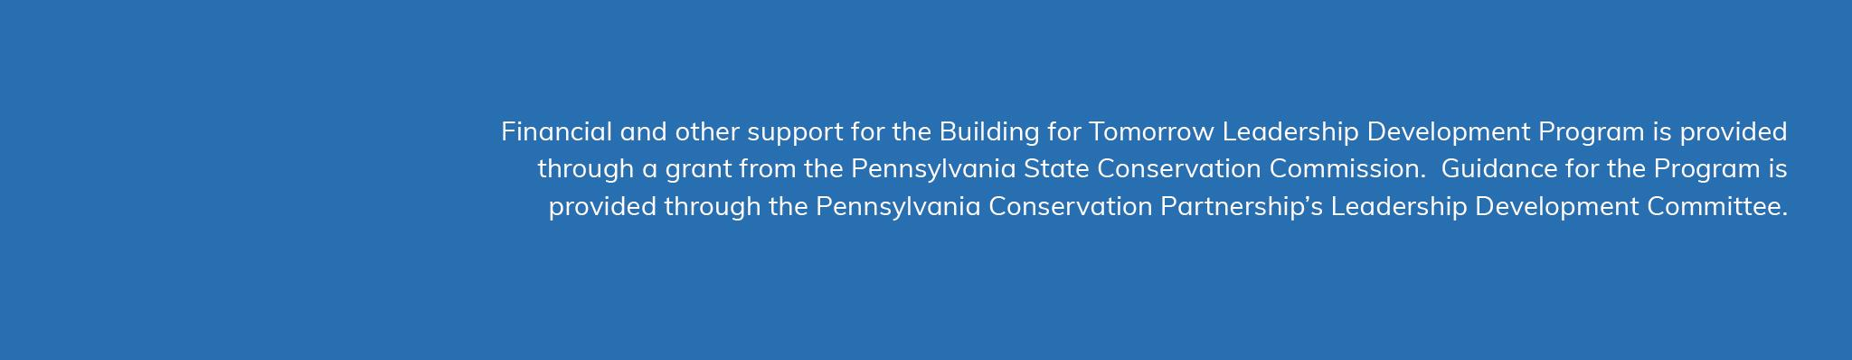
2020 Conservation District Video Awards
Submission Form

RULES
- All submissions must be for video/animated content produced and shared in 2020. Districts are limited to one submission per category.
- All submissions must include a link to video content that was posted publicly on a district website, social media account, or streaming app. Submissions in the K-12 Educational category may also include recorded video presentations via Zoom or other platform.
- All submissions must received by December 31, 2020.

SUBMITTER INFO

District: _______________________________

POC Name:____________________________

Position:__________________________

Email:____________________________

CONTENT INFO

Content Title:_________________________________

Content Link:_________________________________

Content Total Run Time (minutes + seconds):_______

Intended Audience (please highlight 1 category):
- General (district project promotion, general audience info/demonstration, etc.)
- Homeowner (PSA or instructional, promoting specific district initiative or service)
- K-12 Educational (produced specifically for K-12 audiences)

PRODUCTION INFO

Were any video/media professionals (ie. non-district staff) involved in the production of this content? (yes or no) _________________

Please list all capture devices (including cameras & microphones) used in production:_______________________________________________________

Please list all software used in production: ________________________________________________________________

Total costs for production of this content: ________________

