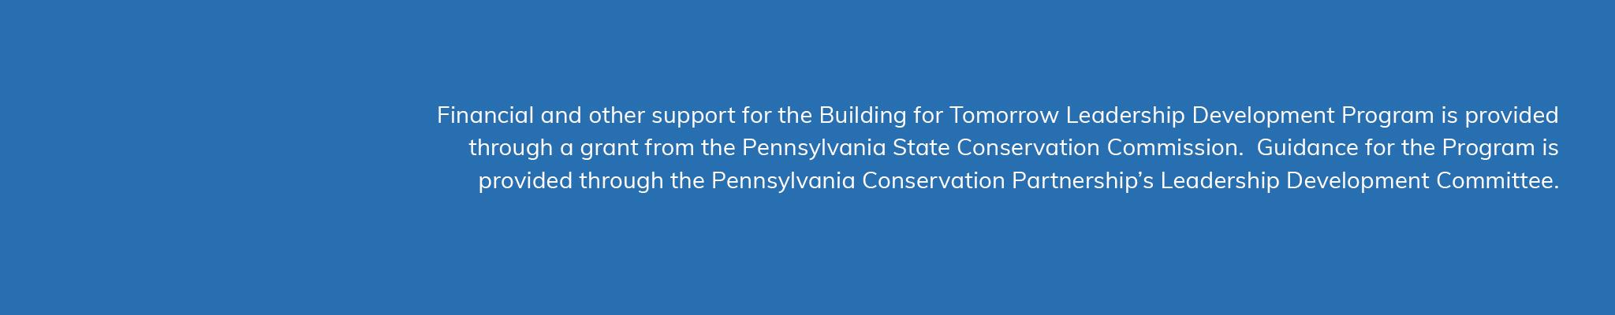**2024 Conservation District Video Awards**

**Submission Form**

**Rules**

* All submissions must be for video and/or animated content produced and shared in 2024.
* Districts are limited to two submissions, and each form must indicate an intended audience.
* Submissions must include a link to content that was posted publicly on a district website or social media account, or to a recording of a streamed presentation.
* All submissions must be received by **January 3, 2025**.
* Finalists will be notified in January and receive instructions to upload a video file for their entry to the contest Dropbox account. Files for finalist submissions must be uploaded by **January 31, 2025**.

**Email completed forms to: mmiller@pacd.org**

**Submission Info**

District: _______________________________

Submitter Name:____________________________

Position:__________________________

Email:____________________________

Content Title:_________________________________

Content URL:_________________________________

Intended Audience:_____________________________________________

List any non-district personnel involved in the production of this content:

_____________________________________________________________